**React Hooks**

Hooks allow us to "hook" into React features such as state and lifecycle methods.

**React useState Hook**

The React useState Hook allows us to track state in a function component.

State generally refers to data or properties that need to be tracking in an application.

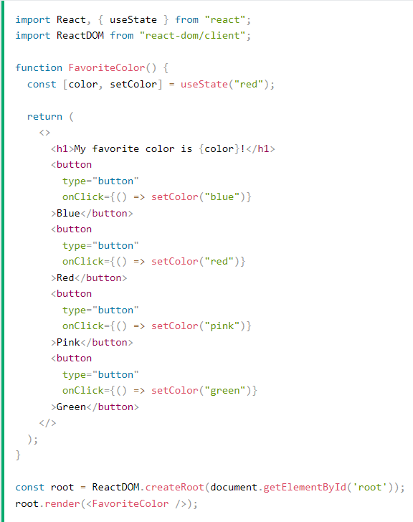

**React useEffect Hooks**

The useEffect Hook allows you to perform side effects in your components.

Some examples of side effects are: fetching data, directly updating the DOM, and timers.

useEffect accepts two arguments. The second argument is optional.

useEffect(<function>, <dependency>)

**React useContext Hook**

React Context is a way to manage state globally.

It can be used together with the useState Hook to share state between deeply nested components more easily than with useState alone.

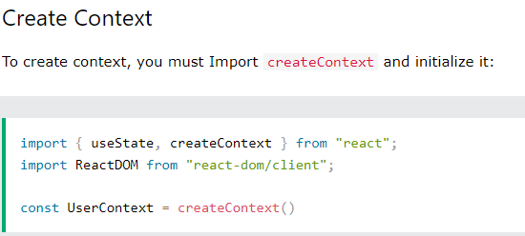

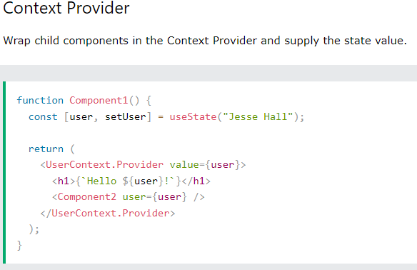

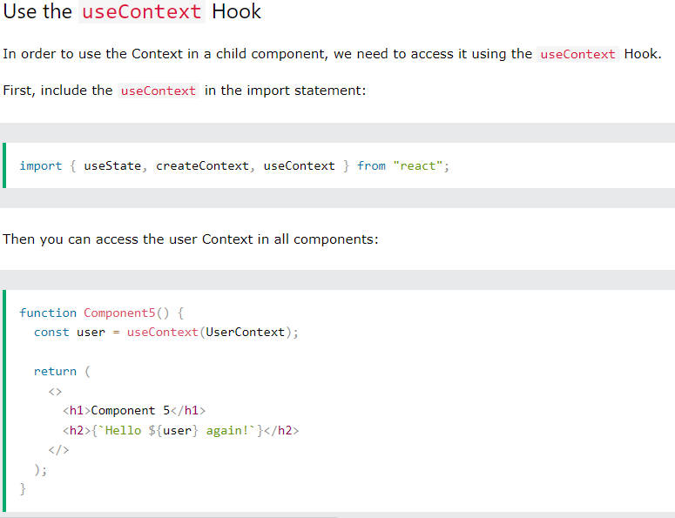

**React useRef Hook**

The useRef Hook allows you to persist values between renders.

It can be used to store a mutable value that does not cause a re-render when updated.

It can be used to access a DOM element directly.

